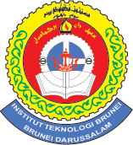

Submitted by:
Amal Nurmunirah Bte Hj.Omar

Submitted for:
Dr. Hj. Kamsani Bin Hj. Ahmad

HND IN COMMUNICATION AND COMPUTER SYSTEM ENGINEERING
Department of Electrical and communication Engineering

OPERATING SYSTEM AND CORE HARDWARE
ASSIGNMENT 2

SUBMISSION DATE
13TH OCTOBER 2012
HARDWARE

1. List down different kind of motherboard for the PC.
- AT Motherboard
- ATX Motherboard

2. What is the different between AX and ATX motherboard? Sketch the layout of the two motherboards.
Difference:
- AT is an old standard replaced by ATX.
- AT boards are wider compared to ATX by almost 4 inches.
- AT computers had their power switches connected directly to the power supply while in ATX systems, the switch is connected to the motherboard.
- Power switch for AT motherboard functions by clicks on and clicks off while an ATX motherboard is a momentary push button that is always open unless pressed.
- AT motherboard uses a two piece single row connector while an ATX’s connector is one piece with two rows of ten connections.
- AT motherboards use two 12-pin plugs to power the motherboard while an ATX’s uses one 20-pin plug for the power supply.

AT motherboard sketch
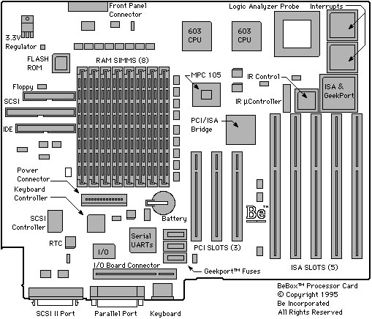
ATX motherboard sketch
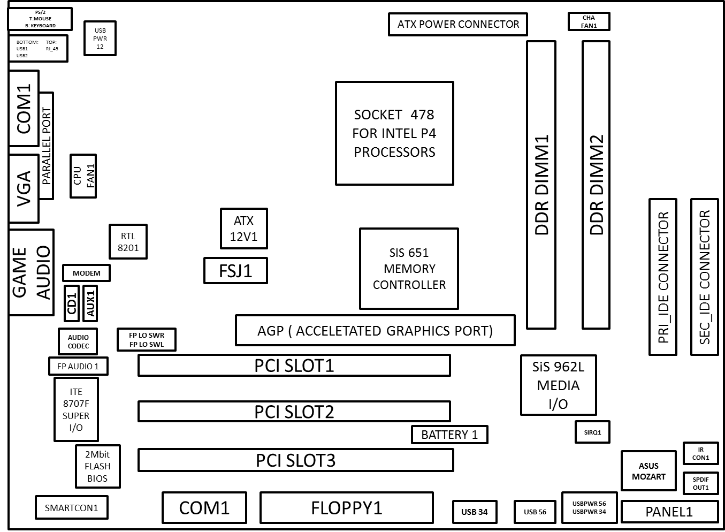
3. List the pins number of various kind of connector on the motherboard and at the back of the PC.

- Parallel Port – 25pins
- VGA Port – 15 pins
- Game Port – 15 pins
- Serial Port – 9 pins
- Mouse Connector PS/2 – 6 pins
- Keyboard Connector PS/2 – 6 pins
- USB Port – 4 pins
- Firewire Port
- Speaker/Microphone
- Internal modem/telephone
- Ethernet network
- Power connector
- Panel connector
- IDE connector

4. What are the DC voltages we can find from the DC power supply?
5V and 12V.

5. List down the electrical problem we are facing when operating our PC?
- Short circuit
- Over current
- Over voltage
- Memory errors
- Data errors
- Reboot

6. What are ESD, EMI and RFI?
ESD – Electrostatic Discharge
EMI – Electromagnetic Interference
FRI – Radio Frequency Interference

7. List different kind of PC storage.
Primary:
- Random Access Memory (RAM)
- Read Only Memory (ROM)

Secondary:
- Hard Disk Drives
- Floppy Discs
- Compact Discs
- Digital Versatile Discs
- Flash memory
- Blu-ray Discs
- USB Flash Drive
- Memory cards

8. List various kinds of RAM and their pin numbers.
- SRAM
- DRAM
- VRAM
- SDRAM (EDO-DIMM) – 168 pins
- DDR SDRAM (DDR DIMM) – 184 pins
- RD RAM/RIMM – 184 pins (16 bit) / 232 pins (32 bits)
- SODIMM – 144 pins / 200 pins

OPERATING SYSTEM

1. What is the function of OS?
It provides a system which allows a person to control the functions of the computer both software and hardware.

2. List down some of the OS that we can use in a small computer?
- Mac OS
- Windows
- Linux

3. What is the different between text based and graphic base OS?
A text based OS is an OS which doesn't have desktop, just text. To let the OS do something, you need to type the command. Only certain applications for this OS use another view then text. A text based OS is for example MS DOS or your computers BIOS. A graphic based OS has a desktop and isn't just text on your screen. Windows 3.1 was the first graphic based OS. More recent graphic based OS are: Windows xp/vista/7

4. List down some of the internal and external command of the text based and briefly explains the function of these commands.
Internal:
- DIR – used to display the contents of current directory
- CLS – used to clear the screen
- DEL – used to delete a file from the drive
- COPY – used to copy any file from one location to another
- MD – used to make a directory
- CD – help to go inside the directory
- CD\ - used to come back to the root directory
- CD.. – step by step come back to the parent directory
- RD – used to remove an empty directory

External:
- EDIT – used to edit any text of DOS
- FORMAT – used to format any drive like hard disk drive or floppy drive
- FDISK – used to perform the partitioning of a hard disk
- CHKDSK – helps to check the currently used drive.
- SCANDISK – checks the drive for error
- MOVE – used to move a file from one location to another
- DELTREE – helps to remove a directory with its contents
- SYS – used to transfer DOS system files from one disk to another
- ATTRIB – display or change the attributes of file

5. What is FDISK used for and then list down the menu that we can find under FDISK.
FDISK is a command line utility that provides and used for disk partitioning functions.
Menu:
- Create DOS partition or Logical DOS Drive
- Set active partition
- Delete partition or Logical DOS Drive
- Display partition information
- Change current fixed disk drive

6. Explain briefly what File System is.
A file system is a means for organizing and storing data and information on a storage device.

7. What is the different between physical and logical drive?
A physical drive is a physical unit that can be handled, also referred as a hard drive or hard disk drive (HDD) whereas a logical drive is a subdivision (electronically) of a physical drive into multiple logical drives or volumes.

8. List down the complete steps on how to install Windows 98 OS?
- Startup – put the Windows 98 CD into the drive and boot the PC
- Menu
- Restart – choose “Start Windows 98 Setup”
- Installation – choose “Run Windows 98 Setup”
- Scan Disk
- Scan Registry
- Copying files needed for installation
- Introduction screen
- Progression
- Directory Selection
- System Analysis
- Installation Options
- Windows Components
- Identification
- Location
- Startup Disk
- Copy files
- First reboot – press OK
- License Agreement
- Microsoft Product Key
- Startup Wizard
- Hardware Configuration Windows
- Restart
- System Configuration
- Time zone
- Restart

9. What is the different between basic and dynamic disk?
- Basic disks are supported by all versions of windows even DOS but dynamic disks can only be supported by later version of windows.
- Dynamic disk volumes can be composed of a set of noncontiguous extents on one or multiple physical disks where by contrast, a volume on a basic disk consists of one set of contiguous extents on a single disk.
- Dynamic disk provides more features than basic disk

